

# Control Line Protector

**Model: WT-101E1**

## APPLICATIONS:

* V.1, X.27, RS485, RS422
* LAN, CAN, V.24/RS232-C, MODEM BUS
* TOKEN-RING, INDUSTRIAL BUS
* Suitable for the signal's transmission rate protection

under the same voltage and same specifications

## FEATURES:

* Low insertion loss, fast response.
* Low limiting voltage
* Precise limiting voltage.
* Strong discharge current

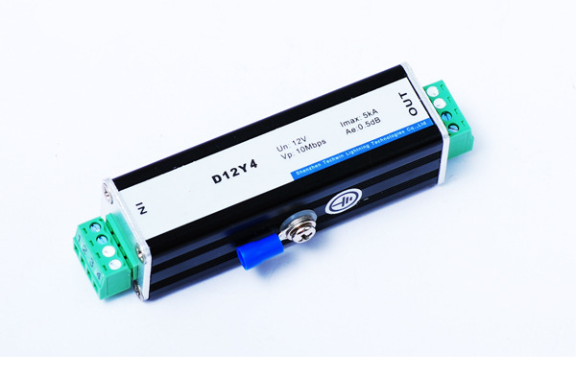

## TECHNICAL PARAMETER：

**Electrical Parameter**

**WT-101Y**

**Model**

Max. continuous operating voltage Uc 12V

Nominal discharge current（8/20µs）In 3kA

Max. discharge current （8/20µs）Imax 5kA

Limiting voltage (10/700µs) Up

Line-line Line-ground

40V

500V

Adapt transmission rate 10Mbps

Insertion loss 0.5dB

Response time tA 1ns

Interface form Compression plug

Protection way 2

Weight per unit 74g

**Mechanical characteristics**

1

Protection port

83(L) ×25(W) ×32(H)mm

Dimension

IP Code IP20

Working conditions Temperature: -40 to 80℃, Relative humidity: ≤95％

Standard IEC61643-1, UL V-90, ROHS

**Welltech Enterprises**

415 Ground Floor, PRAKASH MOHALLA, GARHI , EAST OF KAILASH

NEW DELHI 110065

Phone +91 9871650366 Email : sales@welltechenterprises.in